# **Name: Abdurrahman Qureshi**

# **Roll No: 210451**

Practical No: 5

1) Print the following patterns using loop:

1. **\*  
   **  
   ***  
   \*\*\*\***

CODE:

for i in range(1, 5):

print('* ' * i)

OUTPUT:

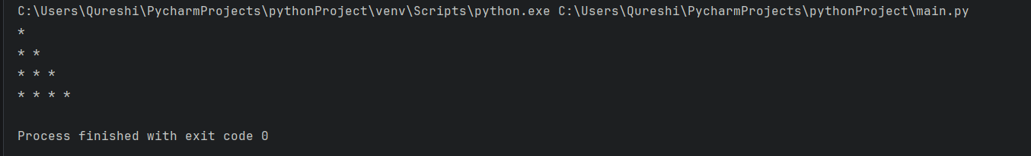

1. **\*  
    ***  
   *****  
    ***  
    \***

CODE:

n = 3

for i in range(1, n + 1):

print(' ' * (n - i) + '*' * (2 * i - 1))

for i in range(n - 1, 0, -1):

print(' ' * (n - i) + '*' * (2 * i - 1))

OUTPUT:

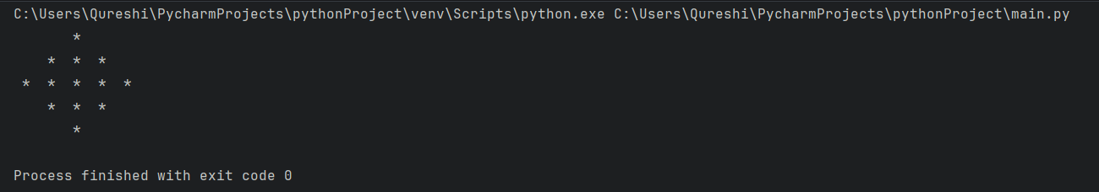

1. **1010101  
    10101  
    101  
    1**

CODE:

n = 4

for i in range(n):

print(' ' * i + '10' * (n - i - 1) + '1')

OUTPUT:

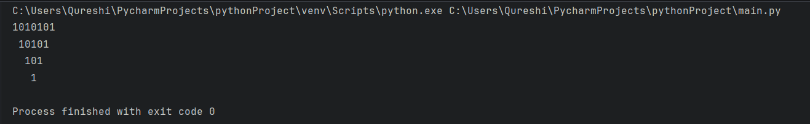

2) Print all even number between 1 to 100 using while loop.

**CODE:**

print("Even numbers from 1 to 100 go brrrrrr.....")  
myNum = 1  
while myNum <= 100:  
 if myNum % 2 == 0:  
 print(myNum, end=" ")  
 myNum += 1

**OUTPUT:**

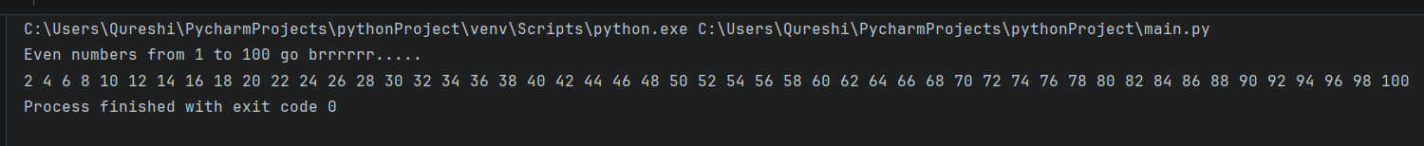

3) Find the sum of first 10 natural numbers using for loop.

**CODE:**

print("The sum of the first 10 natural numbers:", end=" ")

Sum = 0

for i in range(1, 11):

Sum += i

print(Sum)

**OUTPUT:**

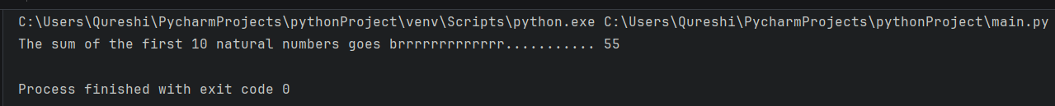

4) Print Fibonacci series

**CODE:**

limiter = int(input("Enter your range: "))  
t1 = 0  
t2 = 1  
t3 = 0  
print(t1, t2, end=" ")  
for i in range(limiter):  
 t3 = t1 + t2  
 print(t3, end=" ")  
 t1 = t2  
 t2 = t3

**OUTPUT:**

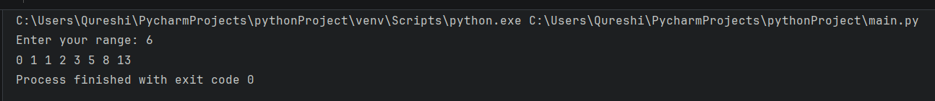

5) Calculate factorial of a number.

**CODE:**

n = int(input("Enter a number: "))  
fact = 1  
print(n, "! =", end=" ")  
while n >= 1:  
 fact *= n  
 n -= 1  
  
print(fact)

**OUTPUT:**

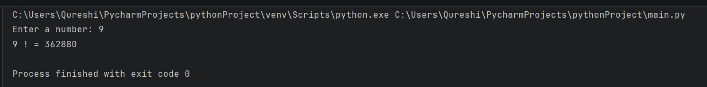

6) Reverse a given number.

**CODE:**

n = int(input("Enter a number: "))  
rev = 0  
mod = 0  
temp = n  
while temp > 0:  
 mod = temp % 10  
 rev = (rev * 10) + mod  
 temp = int(temp / 10)  
print("rev of", n, ":", rev)

**OUTPUT:**

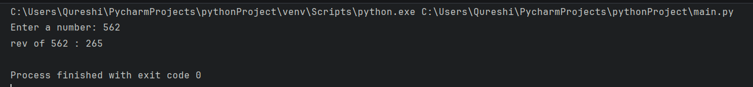

7) Program that takes in a number and finds the sum of the digits in the number.

**CODE:**

n = int(input("Enter a number: "))  
Sum = 0  
mod = 0  
temp = n  
while temp > 0:  
 mod = temp % 10  
 Sum += mod  
 temp = int(temp / 10)  
print("The sum of the digits of", n, "is", Sum)

**OUTPUT:**

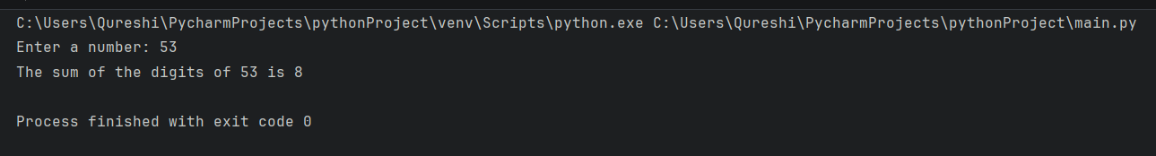

8) Program that takes a number and check whether it is a palindrome.

**CODE:**

n = int(input("Enter a number: "))  
Sum = 0  
mod = 0  
temp = n  
while temp > 0:  
 mod = temp % 10  
 Sum = (Sum * 10) + mod  
 temp = int(temp / 10)  
if Sum == n:  
 print(n, "is a palindrome number. weeee................!")  
else:  
 print(n, "aint palindrome number. bruh")

**OUTPUT:**

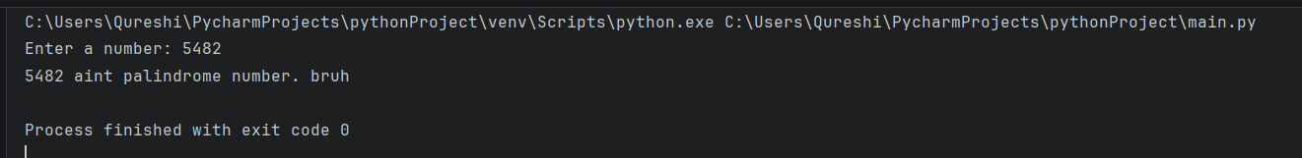

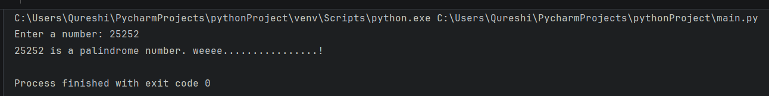

*Extras*

1) Check whether entered number is an Armstrong number.

**CODE:**

n = int(input("Enter a number: "))  
Sum = 0  
temp = n  
mod = 0  
while n > 0:  
 mod = n % 10  
 Sum = Sum + mod ** 3  
 n = int(n / 10)  
if Sum == temp:  
 print(temp, "is an Armstrong number. NOICE!")  
else:  
 print(temp, "aint an Armstrong number. bruh?")

**OUTPUT:**

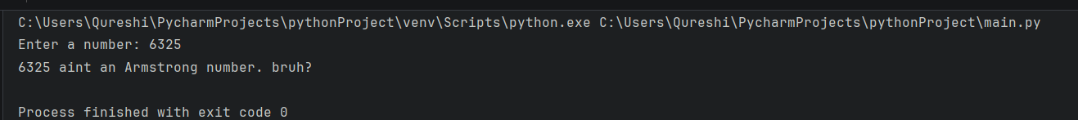

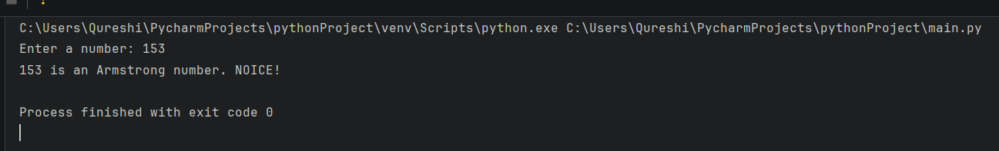

2) Print the table of entered number.

**CODE:**

n = int(input("Enter a number: "))  
i = 1  
while i <= 10:  
 print(n, "*", i, "=", n * i)  
 i += 1

**OUTPUT:**

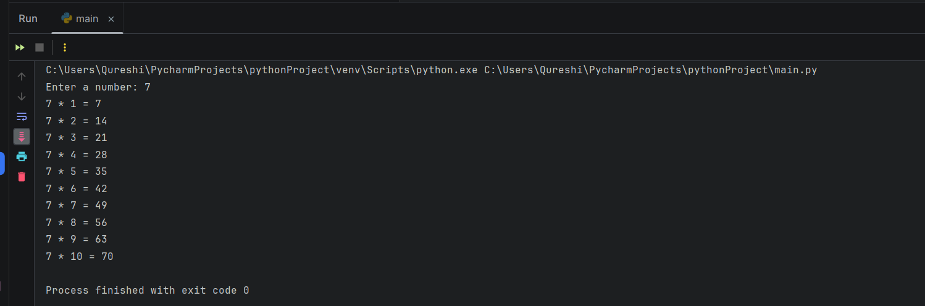

3) Check whether entered number is prime or not.

**CODE:**

n = int(input("Enter a number: "))  
isPrime = True  
for i in range(2, n):  
 if n % i == 0:  
 isPrime = False  
 break  
if isPrime:  
 print(n, "is a Prime number. i go brrrrrrr..........")  
else:  
 print(n, "is a Composite number. bruh")

**OUTPUT:**

